Page 1: Getting Started & Initial Setup

1. Launching the Application
To use Recipease, you need to start two servers:

Step 1: Start Backend Server
Open Terminal 1 → Navigate to backend folder → server.js
Run: cd backend → node server.js

Output:
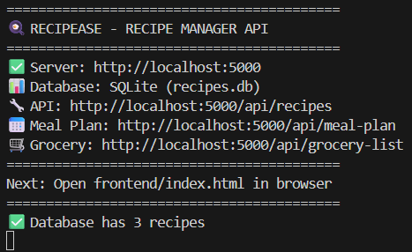
Backend server running on http://localhost:5000

Step 2: Start Frontend Server
Open Terminal 2 → Navigate to frontend folder → script.js
Run: cd frontend → npx http-server -p 8000

Output:
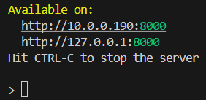
Frontend server running on http://127.0.0.1:8000

2. Accessing the Application
Hover your mouse over each link, hold ctrl + click, and you will automatically be redirected.
Backend server:
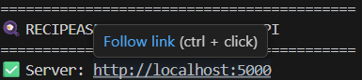
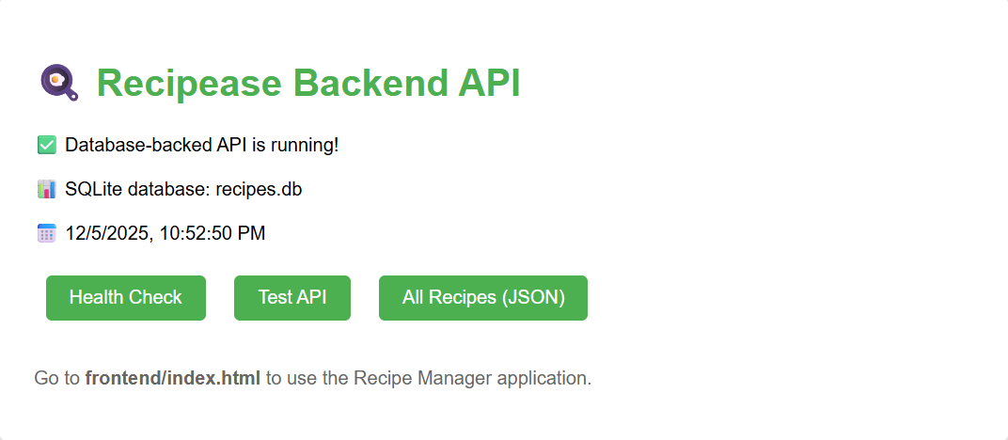
Backend server page which includes a health check, Test API, and all recipes formatted in JSON.

Frontend server:
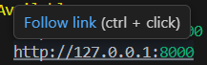

3. Understanding the Interface
The Recipease interface has five main sections:
- 🏠 Dashboard - Overview and quick actions
- 📚 Recipes - Browse and manage all recipes
- ➕ Add Recipe - Create new recipes
- 📅 Weekly Meal Plan - Plan meals for the week
- 🛒 Grocery List - Generate shopping lists

4. First-Time Setup Check
- ✅ Backend connection established
- ✅ 3 sample recipes loaded
- ✅ Database ready for use
- ✅ All navigation tabs functional
Tip: Keep both terminal windows open while using Recipease.

Page 2: Recipe Management

1. Browsing Recipes
Click the "📚 Recipes" tab to view all recipes.
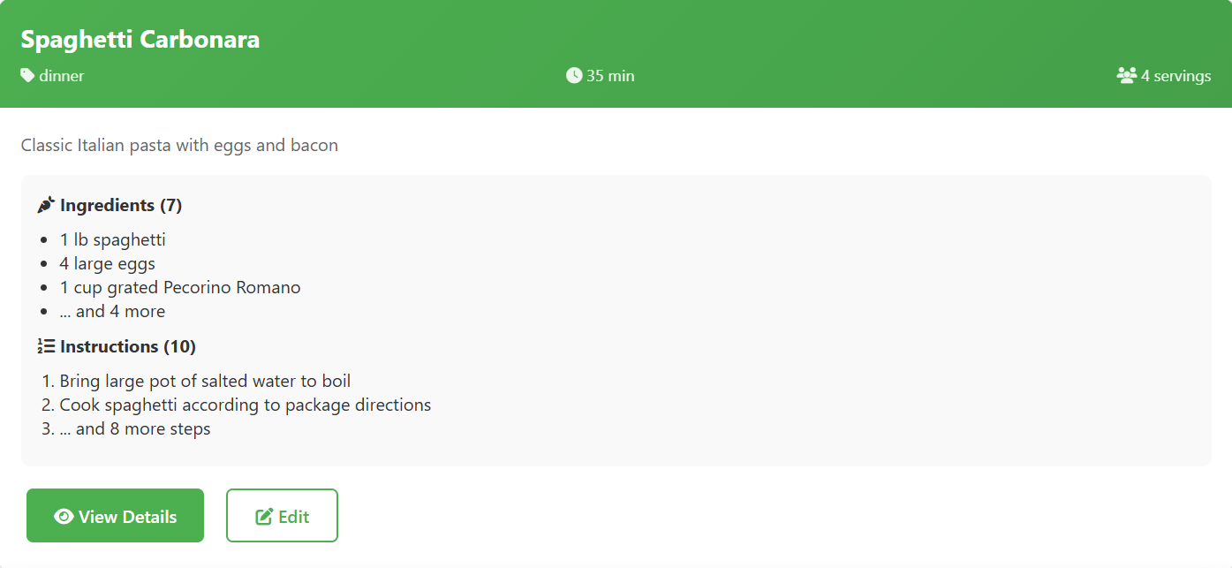
Recipe cards showing title, category, time, and servings.
Each recipe card shows:
- Recipe title, ingredients, and instructions
- Category icon and label
- Total preparation + cooking time
- Number of servings
- Action buttons: View Details, Edit

2. Viewing Recipe Details
Click "View Details" on any recipe card to see complete information.
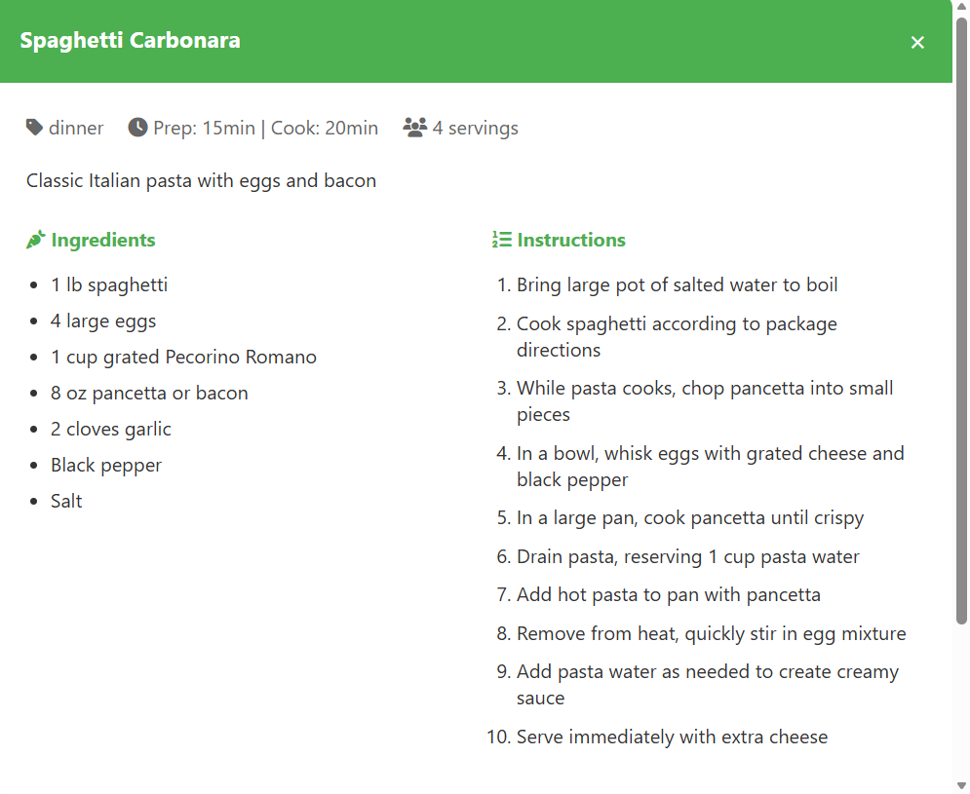

Modal showing complete recipe with ingredients and instructions.
The details the modal displays is:
- Complete ingredient list with quantities
- Step-by-step instructions
- Preparation and cooking times
- Serving information
- Action buttons: Edit Recipe, Close

3. Filtering Through Recipes
Filter: Use the Category Dropdown to select the type of recipe you want to see.
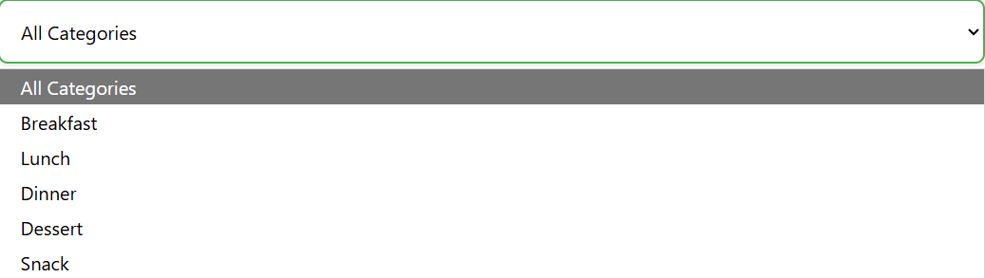

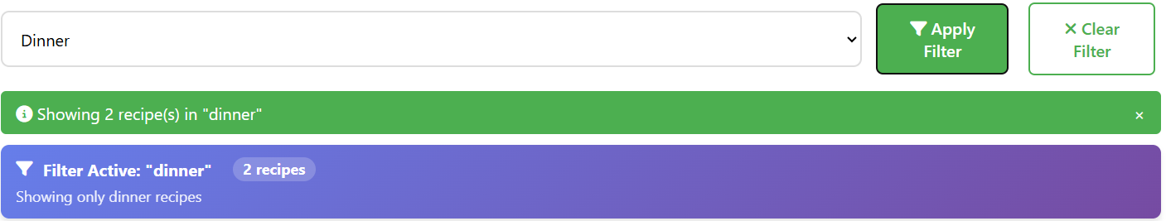When you make a selection, a pop-up will confirm the active filter.

4. Adding a New Recipe
Click "➕ Add Recipe" tab to create a new recipe.
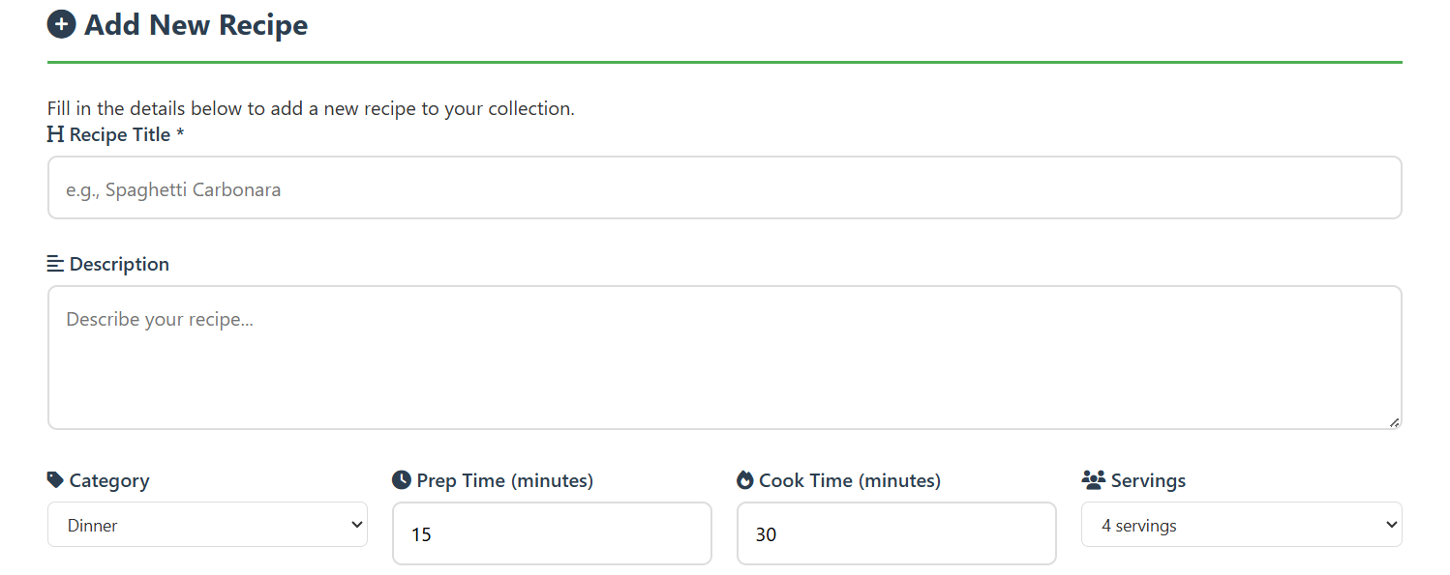
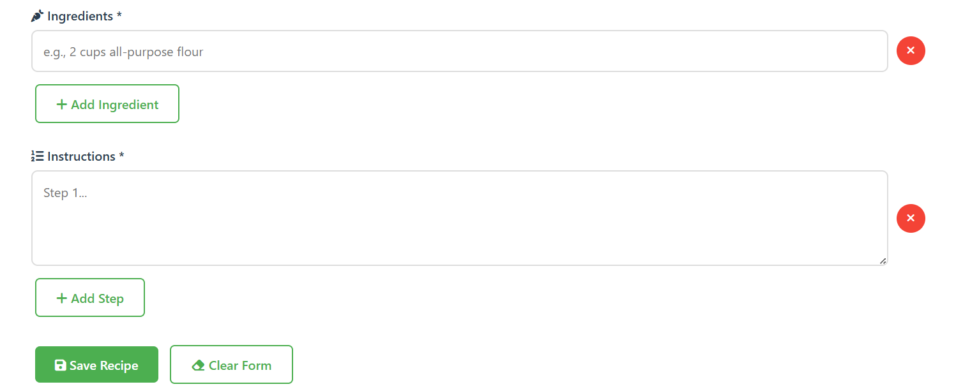
Complete the recipe creation form by filling in the requirements.
Step-by-Step:
- Basic Information:
- Enter recipe title (required)
- Add description (optional)
- Select category from dropdown
- Enter prep and cook times in minutes
- Select number of servings

- Add Ingredients:
- Enter first ingredient (e.g., "2 cups flour")
- Click "Add Ingredient" for more fields
- Use "×" button to remove ingredients

- Add Instructions:
- Enter first instruction step
- Click "Add Step" for additional steps
- Each step creates a new text area

- Save Recipe:
- Click "Save Recipe" button
- Wait for success confirmation
- Recipe appears in Recipes tab
- All recipes will be organized in alphabetical order

5. Editing Recipes
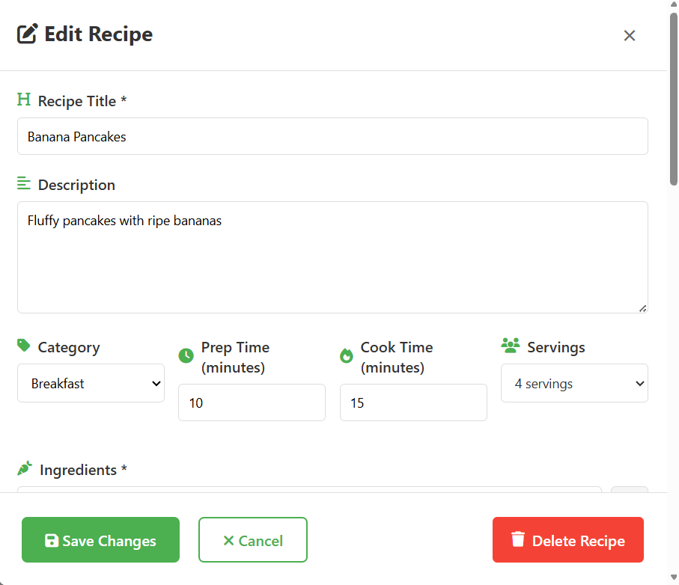
- Click "Edit" on any recipe card
- Modify any field in the edit modal
- Click "Save Changes" to update
- Or click "Delete Recipe" to remove

Page 3: Meal Planning

1. Accessing the Meal Planner
Click the "📅Meal Plan" tab to open the meal planner.
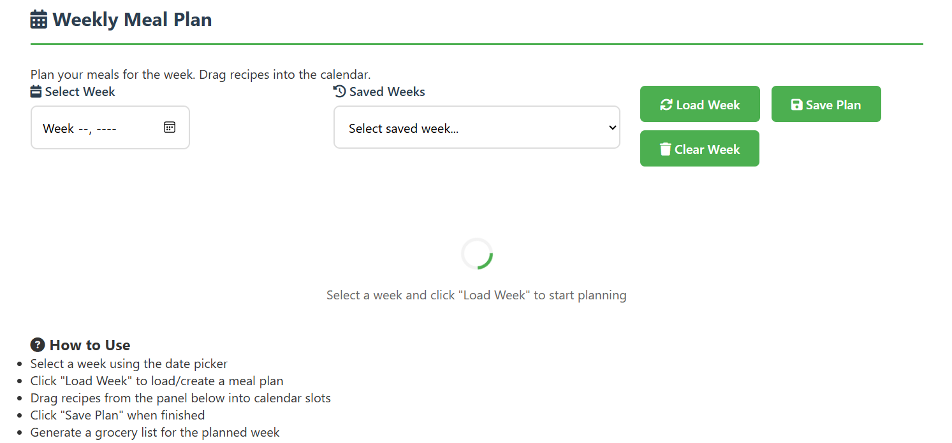

2. Selecting a Week
- Use the date picker to select a week
- Click "Load Week" button
- Calendar loads with any previously saved meals
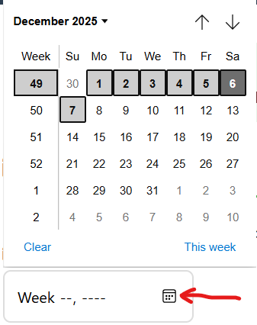
Date picker showing week selection.

3. Understanding the Calendar Layout
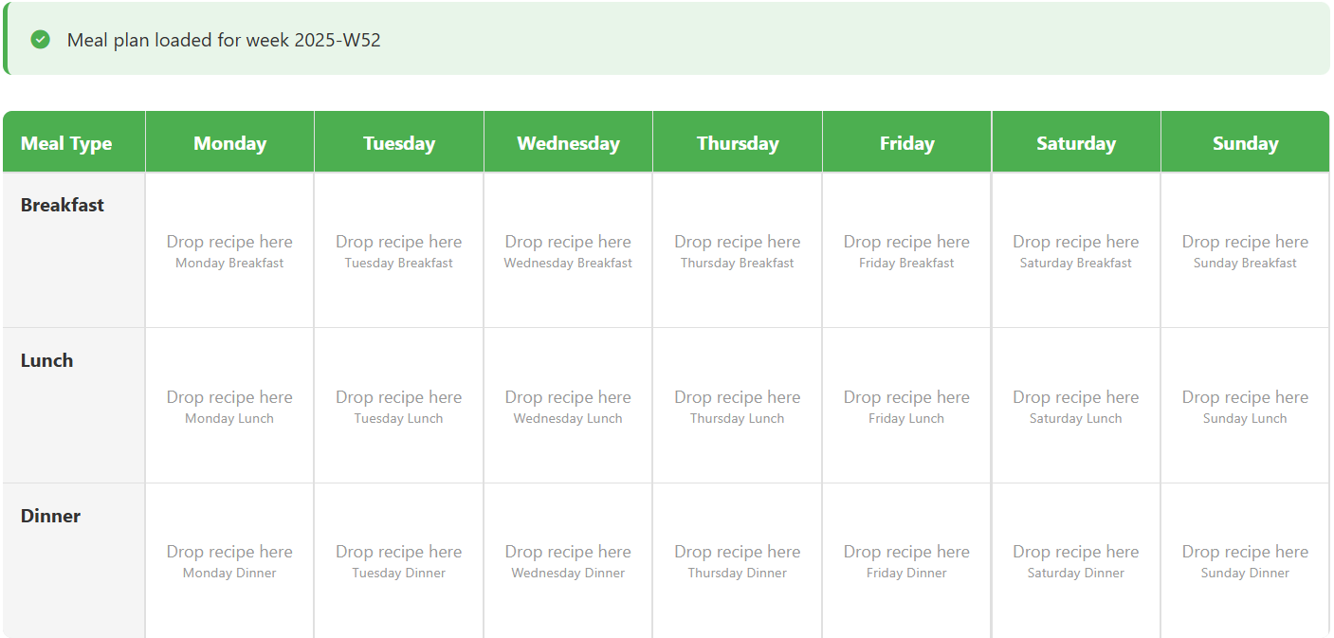Weekly calendar with empty slots ready for planning.

The calendar shows:
- Columns: Monday through Sunday
- Rows: Breakfast, Lunch, Dinner
- Empty Slots: Gray areas saying "Drop recipe here"

4. Drag-and-Drop Planning
Step 1: View Available Recipes
Scroll down to see all your recipes in the "Available Recipes" section.
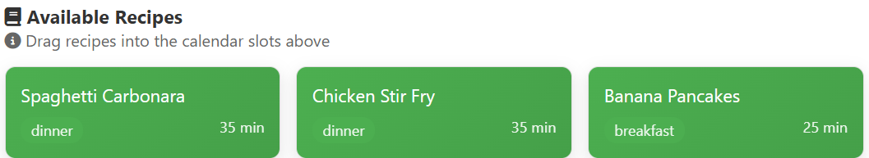
Recipe cards ready for dragging.

Step 2: Drag a Recipe
- Click and hold any recipe card
- Drag it to a calendar slot
- Look for visual feedback (slot turns green)
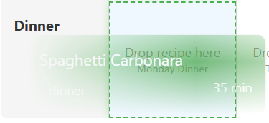
Visual feedback during drag operation.

Step 3: Drop the Recipe
Release the mouse button to drop the recipe into the slot.
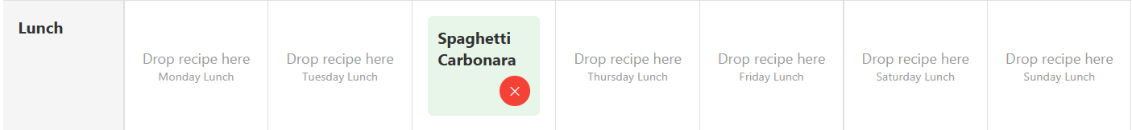
Recipe successfully added to meal plan.

5. Managing Meal Plans
Remove a Recipe:
- Click the "×" button on any planned meal
- Confirm removal when prompted
Save Your Plan:
- Click "Save Plan" button to explicitly save
- Auto-save also occurs during drag operations
Load Saved Weeks:
- Use the "Saved Weeks" dropdown
- Select any previously saved week
- Click "Load Week" to view
Clear Entire Week:
- Click "Clear Week" button
- Confirm to remove all meals
- Use with caution!

6. Meal Planning Tips
- Plan Complete Weeks: Try to fill all meal slots for balanced planning
- Use Variety: Mix different categories throughout the week
- Save Frequently: Click "Save Plan" after major changes
- Review: Double-check your plan before generating grocery list

Page 4: Grocery List Generation

1. Accessing Grocery Lists
Click the "🛒 Grocery List" tab to open the grocery system.
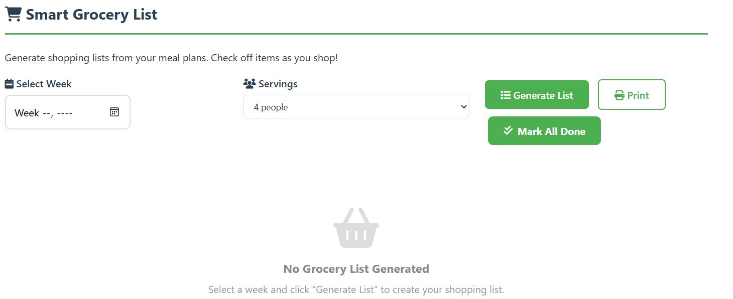Grocery list interface before generation.

2. Generating a List
Prerequisite: You must have a meal plan created first.
Step 1: Select Week
- Use the week selector to choose the same week as your meal plan
Step 2: Adjust Servings
- Use the servings dropdown to scale recipes
- Options: 1 person, 2 people, 4 people (default), 6, 8, 10 people
Step 3: Generate List
- Click "Generate List" button
- System aggregates ingredients from all planned meals
- List appears with all items to purchase

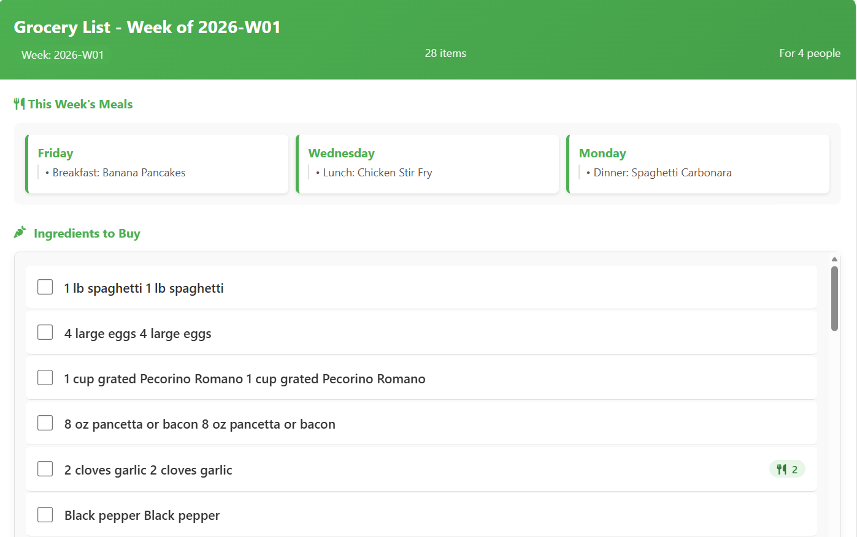
Complete grocery list with items and quantities.

3. Understanding the Grocery List
The grocery list shows:
Header Information:
- Week identifier
- Total number of items
- Servings multiplier applied
- Shopping progress percentage
Ingredient Items:
- Each item with checkbox
- Quantity and description
- Recipe count indicator (how many recipes use it)
- Scaling indicator (if servings adjusted)
Shopping Progress Section:
- Visual progress bar
- Completion percentage
- Status message
- Item count (X of Y completed)

4. Using the Shopping Interface
Check Off Items:
- Click anywhere on an ingredient row
- Item shows strikethrough styling
- Progress bar updates immediately
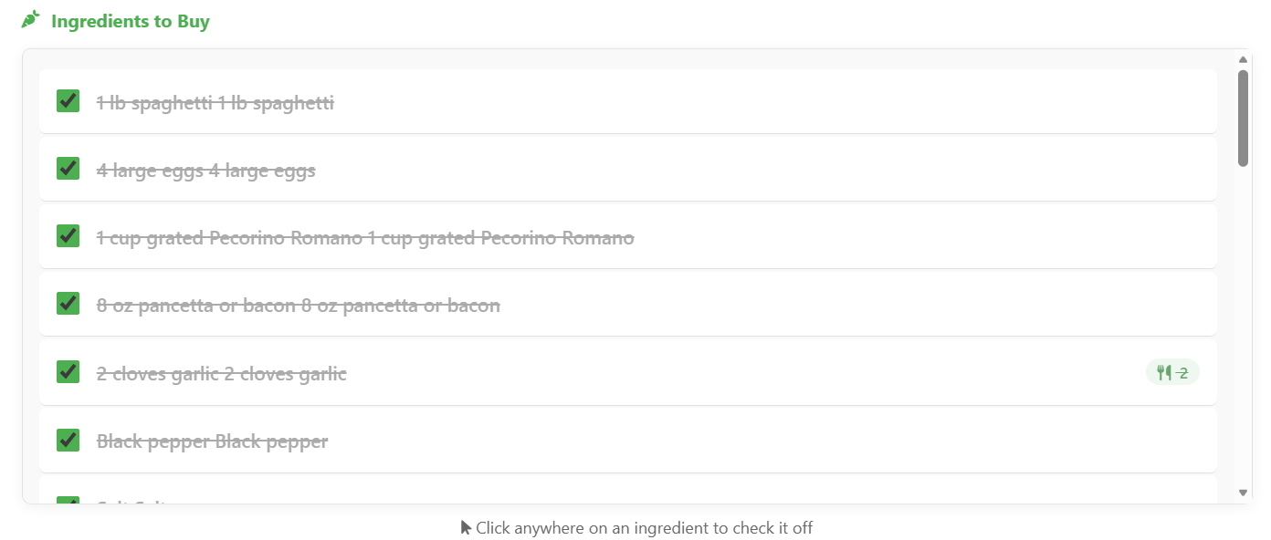
Items checked off with visual feedback.

Bulk Actions:
- Mark All Done: Checks all items at once
- Reset Progress: Unchecks all items
- Print: Generates printable shopping list

Progress Tracking:
- Watch the progress bar fill as you check items
- Status messages change based on completion:
  - 0%: "Not started"
  - 1-49%: "In progress"
  - 50-74%: "Halfway there"
  - 75-99%: "Almost there!"
  - 100%: "Complete! 🎉" (with celebration message)
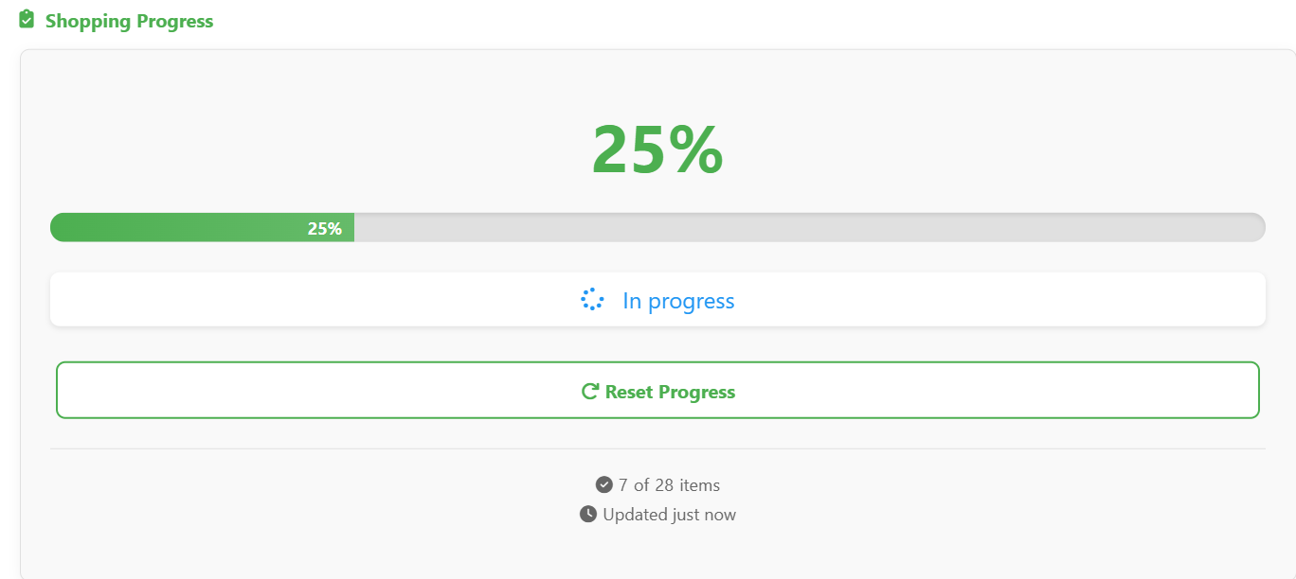
Checked off grocery items update the progress bar.

5. Printing Your List
- Click the "Print" button
- A new window opens with formatted list
- Use browser's print function (Ctrl+P)
- Adjust print settings as needed

The printable version includes:
- Week information
- All ingredients in checklist format
- Shopping tips section
- Print date and time

6. Troubleshooting Grocery Lists
Problem: Empty grocery list
Solution: Ensure you have meals planned for the selected week
Problem: Incorrect quantities
Solution: Check servings multiplier matches your needs
Problem: Progress not saving
Solution: Progress saves automatically to browser storage
Problem: Can't generate list
Solution: Verify backend is running and connected

Page 5: Advanced Features & Tips

1. Dashboard Features

The dashboard provides quick access to common actions:
Quick Action Buttons:
- View All Recipes: Jumps to Recipes tab
- Add New Recipe: Jumps to Add Recipe tab
- Test Connection: Verifies backend is working
Statistics Display:
- Total number of recipes
- Average preparation time
- Number of categories
- Database connection status

2. Recipe Management Tips
Efficient Recipe Creation:
- Use templates for similar recipes
- Copy ingredients from existing recipes
- Use the "Clear Form" button to start fresh
Organization Tips:
- Use consistent category assignments
- Review and update recipes periodically

3. Meal Planning Strategies
Weekly Planning Workflow:
- Start with empty week
- Add staple meals first
- Fill remaining slots
- Review and adjust
- Save final plan
Time-Saving Tips:
- Drag multiple recipes quickly
- Use the auto-save feature
- Copy plans from previous weeks
- Save favorite meal combinations

4. Grocery List Optimization
Before Generating List:
- Review meal plan completeness
- Adjust servings as needed
- Check for ingredient overlaps
During Shopping:
- Use the progress tracker
- Check items immediately upon purchase
- Use the printed list for offline shopping
After Shopping:
- Reset progress for next time
- Save successful shopping lists
- Note any substitutions made

5. System Maintenance
Regular Tasks:
- Verify both servers are running
- Check database connection status
- Clear browser cache if issues arise
- Refresh the page

6. Best Practices Summary
- Always save after major changes
- Use auto-save features where available
- Regularly back up important meal plans
- Test connections before starting work
- Use the print function for physical lists
- Explore all features to maximize efficiency

7. Keyboard Shortcuts
While not extensive, some useful shortcuts:
- Tab: Navigate between form fields
- Ctrl+P: Print grocery lists
- Ctrl + F5 to refresh page

Getting Help
If you encounter issues:
- Check Console: Press F12 → Console tab for error messages
- Verify Servers: Ensure both terminals are running without errors
- Test Connection: Visit backend server http://localhost:5000 and run a health test
- Clear Cache: Try clearing browser cache and localStorage
- Restart: Close and restart both servers

Summary
Recipease provides a comprehensive solution for:

- Recipe Management - Store, organize, and search all your recipes
- Meal Planning - Visually plan weekly meals with drag-and-drop
- Grocery Lists - Automatically generate shopping lists from plans
- Progress Tracking - Monitor shopping completion in real-time
Getting the Most from Recipease:
- Start with the sample recipes to learn the interface
- Plan complete weeks for best grocery list results
- Use all filtering options to organize your recipes
- Take advantage of the auto-save features
- Print lists for offline shopping convenience
Happy cooking and meal planning with Recipease! 🍳📅🛒
Thank you!

